Speech by John Dodwell, a Trustee of the Canal & River Trust, to a Meeting of the Stort Boat Club at 7.30pm on Saturday March 22 2014 at Roydon Church Hall, Essex
This Club is at one end of the national network – yet its members travel far and wide. There is at least one member who has travelled to the other end – sorry Mimi Alderman isn’t here – and has gone on tidal waters to get to the Lancaster Canal. My wife and I remember being part of the Club’s contingent at Beale Park on the Thames at an IWA National – we were moored sixth out!
I was asked to talk about “Current Waterway Matters, including Licence Enforcement and Moorings” so let’s start with licences and moorings – those are some ticklish subjects! - and see how we get on with current matters – I’m conscious that I stand between you and your supper.
Licencing
Licenced boats on the BW/CRT system rose over 10 years from about 25,000 to 35,000 – about a 40% increase. A small part of this was due to getting the licence evasion rate down from 10% or so to the present 3-4% - which was the position when the Trust took over in July 2012 and it’s stayed at about that level. In the London area (which includes the Stort) it was 5.7% at the annual check (which about a year ago).The March 2014 annual check is currently underway; indications to date are that the evasion rate in London is likely to be shown to have risen slightly; and that there has been a significant rise in the number of boats, especially on the eastern section of London.
In the latter BW period, licence fees went up by inflation + 2% and the rate of increase was fixed for three years so people had some certainty. Currently, the Trust has said the increase will be at the rate of inflation – i.e. not plus 2% (unlike the EA, still under Government control). One reason for this is that boat numbers are now about static – as a result, I suspect, of the recession – which, we are told, is on the way out. As a boat owner myself, I don’t like the cost of boating to go up but I know that for many people mooring costs are actually a greater proportion of the whole. I’m also perhaps more conscious than many that the Trust can make very good use of any extra income it gets. Contrast that with people who argue for lower licence fees but higher spending on maintenance!
What happens when people don’t pay their licence fee? Look on the Trust’s website at http://canalrivertrust.org.uk/publication-scheme/publication-scheme/court-action-to-remove-boats-from-our-waterways for the warnings given but in due course the Trust has to resort to legal action. This varies, according to whether a boat is being lived on. But eventually, the Trust exercises its legal rights to remove the boat – you may have heard of the Section 8 & 13 process.
And this process is used. The Trust works to a 31 March year end and in the year to 31 March 2013 72 boats were removed from the waterways. So far this year and up to the end of February 2014 58 boats have been removed.
If you see a boat without a licence disc, it needn’t mean it’s unlicenced. The easiest way for you to check is look on the Trust’s website at put in the boat’s numberhttp://canalrivertrust.org.uk/boating/licensing/boat-check.
Just put in the boat’s number and you can see if it’s licenced. The Trust does have its own checkers but – as they say – every little bit helps. In the July- September period in the summer last year, users reported 370 cases of unlicenced boats. 64% of these were already in the enforcement process and 27% subsequently re-licenced. 2% resulted in the Trust starting enforcement proceedings. 5% were about boats on non Trust waterways. The final 5% - about 18 - were boats without a valid number and were passed onto the enforcement teams. So thank you to everyone who took the trouble to go on-line.
Not licencing a boat can be expensive. Here’s an example. A fire damaged boat on the Trent & Mersey – unlicenced – was about to be removed from the water last year when the owner came forward – just as the boat lift started! After what was described as “a long conversation”, the owner agreed to pay nearly £5,500 to cover the cost of the abortive lift and outstanding fees. As Denise Yelland, the Trust’s head of enforcement, said in a Press Statement to publicise the Trust’s action “It’s not fair for the majority of boaters that a minority try to get something for nothing. We don’t like having to take boats out of the water……[but] we will continue to crack down on those boaters who aren’t playing by the rules”.
There’s a question at the end from Glynis Dennis which will cover what happens when there’s someone living on a boat who needs help so I’ll deal with that then.
Mooring
There are different types of moorings so far as the Trust is concerned. They include marina moorings, on-line towpath moorings, offside moorings, end of garden moorings, residential moorings and so on. Then you have boats without a regular mooring (in the jargon, that’s without a home mooring). The general rule is that when moving around, you can moor anywhere for up to 14 days – unless there is a sign saying otherwise. For myself, I have a boat – HELEN, a 51ft old BCN tug which draws 3 ft – and have a home mooring at a small boat yard. Come the spring, we start travelling around, leaving the boat up to 14 days here or there and for longer periods at a boatyard/marina before getting back to base in October. Last year saw me on the Basingstoke, Wey, Thames, GU and Oxford and the previous year saw us on the Huddersfield Narrow and the Rochdale etc. The plan this year is Sharpness before Stratford to celebrate 50 years since David Hutchings re-opened the Stratford Canal and then via the BCN and the Shropshire Union and Middlewich to the Caldon to celebrate 40 years since that Canal was restored. So that’s my personal interests disclosed!
There are quite a number of visitor moorings – generally near popular spots and with less than 14 days allowed.
The Trustees are well aware there are problems about moorings. Indeed, one of our first decisions – back in autumn 2012 – was to task the staff with looking for ways of resolving the problems. This has resulted in staff recruitment and some new thinking.
In recent years, problems have arisen in connection with people over staying, including at visitor moorings. There’s a question at the end about whether 48 hours means 2 days so I’ll leave that till then. There’s been a fair bit of confusion about what a visitor mooring is. What you see now has rather grown like Topsy over the years and boat numbers have increased and so the Trust is reviewing the whole picture. I’ve seen some signs limiting mooring to 14 days – which doesn’t make sense as you can stop anywhere for up to 14 days. Perhaps it might better be called a short term mooring. There’s been a lot of consultation over the last 12 months or so with some trials at Stoke Bruerne, Foxton and Thrupp on the Oxford. The Trust’s Navigation Advisory Committee is looking at this too, as is a sub group of the South East Waterways Partnership and, in London, the Better Relationships Group. Various national organisations are meeting the Trust later this month.
There have been suggestions that over stayers are always those with continuous cruising licences but as you can’t tell when a boat arrived if you came along after it, I’m not sure that’s right. It might be people with home moorings moving around but who have stayed for more than two weeks. What I do know is that if you arrive too late in the evening at a very popular place, you may well find it difficult to tie up as other people may have got there earlier in the day. That happened to me at Thrupp last September at 7pm. I reckon we need better signage – under consideration – and more short term moorings in certain places. Not always possible, of course –for example, there is no more room in that short stretch above Stoke Bruerne Top Lock up to the Tunnel. But maybe at some of the pubs we can all link up - with the pub and local shops paying for the moorings rings or bollards which are then installed by volunteers.
We have the vexed question of people who live on boats and don’t have a home mooring and then don’t move around as they should – and I don’t think you’d expect me to ignore that. May I try and clarify a few matters?
Living on a boat can be a great thing. Of course, it is not for everyone, and is an individual lifestyle choice, but for some it becomes a lifetime passion and it adds an extra dimension to our living waterways. But there is a proviso - you have to abide by the rules.
Some people have a residential mooring. Indeed, the chair of the Residential Boat Owners Association lives on his boat in such a mooring not very far from where we are here in Roydon. The RBOA, by the way, tell me that when people ring them up about living on a boat, they make the point that it should not be regarded as cheap housing and that you need an empathy with the waterways. Where possible – and that means dealing with local council planners – the Trust’s marina subsidiary has been increasing official residential berths and the Trust is trying to find more in London. Three small new moorings – near Acton’s Lock on the Regents, Alperton on the Paddington Arm, and Homerton on the lower Lee – are due to be completed by the Trust in 2014, providing 19 residential berths. Not a lot, you may say, and you’d be right. So you’ll be glad to hear, I hope, that the Trust has found 30 offside sites in this area which although not large enough to be commercial viable moorings might be of interest to small groups to run by themselves. The Trust is now developing guidance for people on how they can go about creating such sites.
Living on a boat is also Ok if you don’t have a regular mooring, keep moving “in the course of bona fide navigation” and don’t stay more than 14 days in any one place. Now, that’s paraphrasing and I hope no-one will take me to task for that shorthand. There have been court decisions on exactly what this means but I doubt if you here tonight want all the details. Let me make one thing clear. The Trust welcomes this type of continuous cruisers among the other users of the waterways – they add vibrancy to the waterways and they can, if they wish, be an extra pair of eyes and ears for the Trust.
But then we have those who don’t pay for a mooring and also don’t move as they should. In the first place, proper enforcement should help and you’ll have noticed more of this, especially as the people previously catching up with licence evasion have been able to look at mooring problems. But it’s never as simple as you would like, is it? The Trust has inherited cases where there has not been proper enforcement and people have been allowed to put down roots in an area. Just enforcing – as it were – overnight that such people must move on will create other problems.
So the Trust has been looking for solutions. At one time we thought we had an answer with the concept of a roving mooring permit where people already in breach of the rules would be allowed to stay in a small area as long as they moved around – but late in the development stage, this fell foul of legal advice.
There have been problems of this type at the western end of the K & A. After extensive discussions including a consultation put out by the local Waterways Partnership, the Trust is implementing – as from 1 May this year – a plan whereby boaters without a home mooring will not face enforcement proceedings for a 12 month interim period if – and it’s a very important “if” - they adopt a range of movement and moorings described in the plan.. Over the 12 months period, boaters must move between Bath and Foxhangers (at the bottom of the Caen Hill flight), spending a reasonable period of time at each neighbourhood. Simply doing the journey there and back in a quick trip and then not moving for the rest of the year won’t count! The purpose is to allow such people time to regularise their movement so that after the 12 months they can then comply with the usual rules.
With effect from 1 January this year, people applying for a continuous cruising licence are told clearly that they can’t expect to tie up anywhere and then not move for weeks on end. The rules are made clear to them plus the fact that their movement will be monitored.
What might all this mean for moorings in the London area – where the Trust knows very well there are problems? There are lots of interests to be considered – people who live on their boats (whether they obey the continuous cruising rules or not); people who have a home mooring in the area and so have somewhere to return to; people coming into London and needing short term moorings; people renting out their boats as accommodation; people who carry on a trade from their boats; people who live in nearby houses and who dislike generating engines being used in anti-social hours or smoke from boat chimneys; etc.
So Sorwar Ahmed, the Trust’s new boating liaison manager for the London area, has asked people to join a Better Relations Group, drawn from the interests I’ve just described and now has a group of about 20. One of the merits has been to enable people with differing interests to get together and better understand each other’s points of view. Something which has mildly surprised me as a Trustee is the extent to which people don’t talk to each other and so assume they know the views of others. So these meetings have at the very least helped people to get a better understanding of what others think – and why they think so.
Please don’t expect quick results. Some matters will improve by people better understanding what’s OK and what’s not OK – such as mooring at lock landing stages (which isn’t on). But let me give you two small examples of what’s happening.
At Noel Road, Islington, last December, the Trust began trialling a ‘caretaker boater’ at the Islington visitor moorings aiming to improve relationships with neighbours concerned about noise and smoke and helping to manage the moorings sensitively by limiting the number of boats there and how far abreast boats could moor. A monthly report is produced about boat sightings there, enforcement actions and the substance of complaints. Complaints appear to have been going down since the trial started.
The Trust’s new Mooring Rangers have been developing boater relationships and widening their patrols from the Regent’s Canal to the Grand Union Paddington Arm and the Lower Lee. I am told they are being effective in dealing with boater concerns more quickly – such as repairing boater facilities and liaising with the police about thefts and with the local council about rubbish bin emptying. A monthly report is produced about boat sightings there, enforcement actions and the substance of complaints. Complaints appear to have been going down since the trial started. These Mooring Rangers and the enforcement staff are part of a better communication/behavioural change process which the Trust hopes will result in better compliance with the rules.
In the Paddington area, there has been a consultation about a few possible changes about short term staying and places for trading boats, with a view to getting them in the right places – e.g whether trading boats are better moored by the station exit onto the towpath where there is more passing trade. Visitor moorings in Little Venice and into the Basin are checked daily by a mixture of the Mooring Rangers and the property company’s security team.

You can follow what’s happening about moorings policy by going to the weblink on bi-monthly Towpath Mooring Management reports link http://canalrivertrust.org.uk/boating/mooring/mooring-rules/towpath-mooring-project

What else has been happening?
Let me move onto what’s been happening in the last 12 months or so – and the future. One key event has been the arrival of Richard Parry as the new Chief Executive – some of you may have met him. Whilst it’s generally known that he’s been getting out on boats, his childhood canal holidays are less known. He was with me last autumn on my boat going down Stockton Flight on the GU to Leamington and he was obviously very comfortable both in steering my boat and in working the locks. He’s keen to meet as many users as possible and the boaters’ meetings he’s been holding have usually been attended by 100 or more people. You are probably already aware of his London meeting on April 16 and of his regular meetings with the waterways press. It takes time to reflect on what people have to say, so don’t expect instant results – who was it who said “get two boaters together and you’ll get three views?” – and with the increased consultations the Trust now goes through it takes time to start changes and then time for their effect to be seen. But I have already given you some examples of where things are moving – i.e. on new continuous cruisers being monitored to check they do keep moving and on visitor moorings.
And Richard Parry has told the staff that learning to be open and to embrace genuine involvement might mean resisting an instinct to do things as in the past; and that instead staff must make time to listen to other, consult on decisions – and explain what the Trust is doing - and why.
As part of keeping in touch better, “Boaters Update” now appears twice a month. I gather it is sent to about 25,000 people. So if you don’t get it, then let us know. The link to “Boaters Update” is www.canalrivertrust.org.uk/boaters-update
Trees and Dredging
The Trust has been listening to what people say bothers them – overhanging trees and dredging are two examples. I expect you’ve all heard about the extra £2m allocated for cutting offside trees etc this winter. (Here’s something about the tree cutting profile and a couple of before and afters).
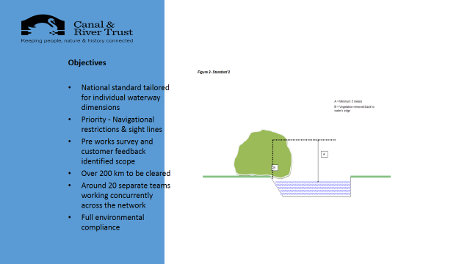

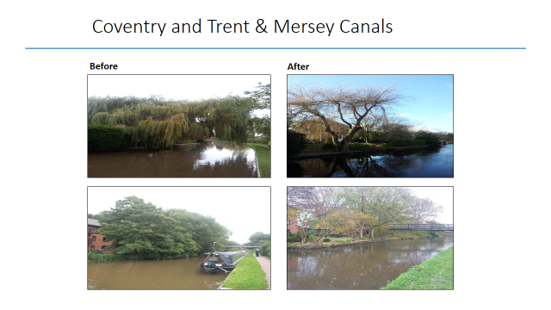
By the way, if you hear people grumbling too much is spent on water voles or otters, you can remind them that vastly more is spent on navigation matters. That’s where the bulk of the money goes and where most of the staff spend their time. And, anyway, I don’t know about you, but I think having wildlife and wild plants is all part of the intrinsic attraction of the waterways. It may help to point out that helping voles is usually done as part of bank protection works that would be done anyway.
Whilst on the subject of helping people understand, I might also explain that generally speaking when you see large towpath works, they’ve been funded by local authorities etc –not wholly out of the Trust’s money (albeit that the Trust may sometimes provide a small sum in order to attract the larger amount). You’ll see such works soon in West Leeds, East Manchester and Birmingham under a £10m Government funded scheme about cycling – the Trust aims to get bank improvements as well as towpath surfacing.
With dredging, the Trust has committed itself to spend £80m over a ten year period – about double the previous rate.
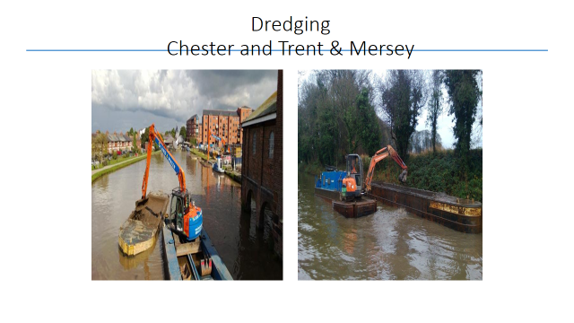
The Trust works to a 3 year plan and the 2014-7 dredging programme includes – starting from the north - places on the Selby, Calder & Hebble, Huddersfield Narrow, Leeds & Liverpool, Trent & Mersey,Erewash, River Soar, Leicester summit, Ashby, Birmingham & Fazeley, BCN, north Stratford, Staffs & Worcs, Mon & Brec, K&A, GU. Each year is due to see dredging at Gloucester, the Ribble Link and, in alternate years, on the Weaver where the River Dane brings in silt. If you want to know where on each waterway dredging will be done, you can go to the website link http://canalrivertrust.org.uk/our-work/dredging/dredging-strategy and follow the lead to the three year dredging plan. And before you tell me, the Trust knows there is more to be done!
Now, I’d make two points about the dredging list I gave you. The first is how it’s decided. This is partly from electronic dredging surveys which are carried out every eight years. But also by what the Trust hears from users. So, if there’s somewhere you think needs dredging, then do, do please let your local waterway manager know.
My second point is that I don’t guarantee this work will definitely be done. Plans can be upset by the unexpected. The Trust does have a £2m contingency in the budget each year. One year it was taken by the Dutton breach and this financial year it was allocated to trees cutting – and then afterwards along came the flood damage! Another example of the unexpected is the Aylesbury Arm lock wall collapse – see this photo.
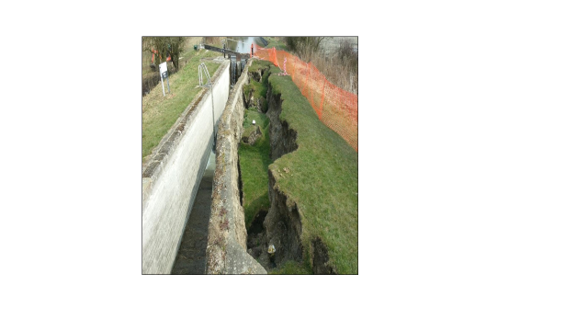

And significant towpath slippage on the Mon & Brec,
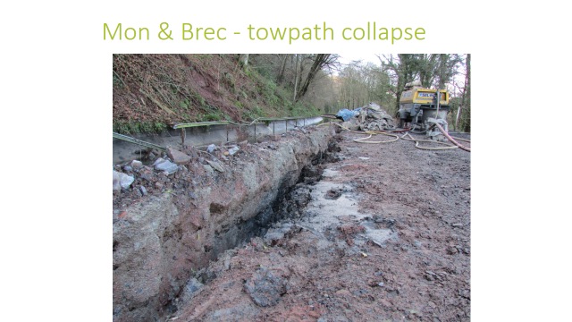
followed by works on Wolverhampton Lock 20 and stopping a bad leak in the Minworth flight on the outskirts of Birmingham.
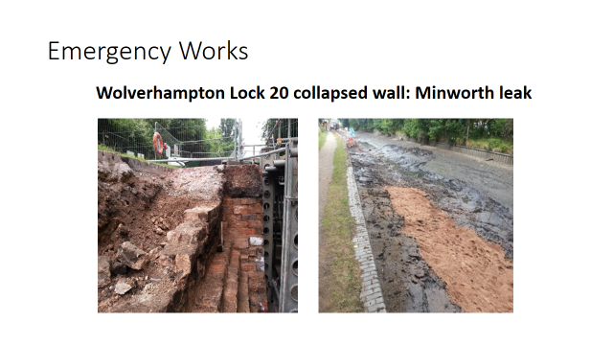

So plans don’t always work out as expected. I suppose it’s a bit like the owner of an old house. He plans to repair a wall but then then his available money for the year gets used up when the roof starts to leak. With old properties – which is what most of the canal system is – it’s a never ending job to try and keep on top of things.
Major Works
May I now turn to major repair jobs? You may know that the smaller jobs get done by the local staff; more significant works are organised centrally. Lock gates replacement is part of the local budget; there is about a £5m budget per manager for all the work in each of the 11 waterways managers. Here’s the 2014-5 lock gate replacement plan.
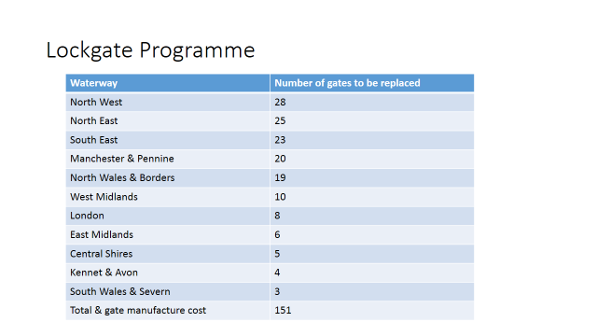
The Major Works programme for 2014-5 is just being finalised and the plan is to spend about £26m, including about £7m on dredging. This £26m includes the £2m annual contingency I mentioned earlier. The planned works, which are subject to no unexpected significant problems elsewhere, include £6m on embankments and culverts. There’s nearly £5m on water management – another not very visible aspect. £1.5m is earmarked for tunnels and cuttings. £2m is for locks includes £500,000 for the Manchester & Pennines region. . Now, a lot of this work isn’t very visible but it is rather – what shall I say? - “ rather important” – to keep the water in the right place.
The bridge works section includes the balance of renewing Sutton Weaver bridge on the Weaver begun last year – overall cost some £4.5m. Under old legislation, the Trust is responsible for the bridge – but only so it is fit for the traffic of the 1920s. As the bridge now carries 20,000 modern vehicles a day, the local authority is paying about £3.5m as they want it used by modern traffic – you may imagine how hard those negotiations were!
I can give you a clue about future spending. With all the caveats I have given, the Trust plans to increase Major Works spending, including dredging, from that £26m to £30m in 2015/6 and also in 2016/7.
Floods
I mentioned floods earlier. I doubt if you need any reminding of the last few months.
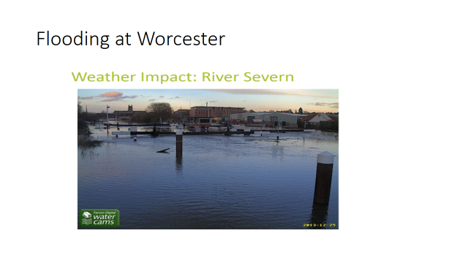
Above is Diglis canal locks at Worcester. February was probably the worst month for the Trust with certain parts – e.g. on the Severn – under water for weeks, causing problems with the electrics at locks, and leaving debris and mud around locks. On parts of the lower Grand Union and the south Oxford, water rose over the towpath or conversely river water rose into the canal. Jon Guest, London waterways manager, said the flooding was the worst he remembers seeing in his 28 years with BW/CRT.
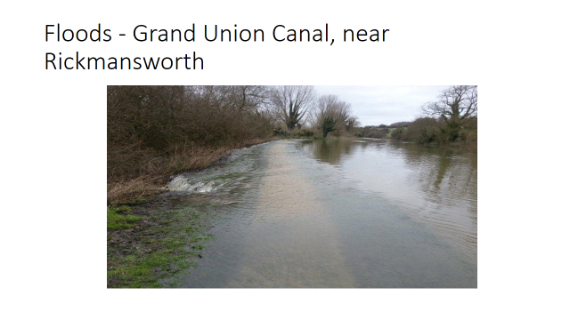
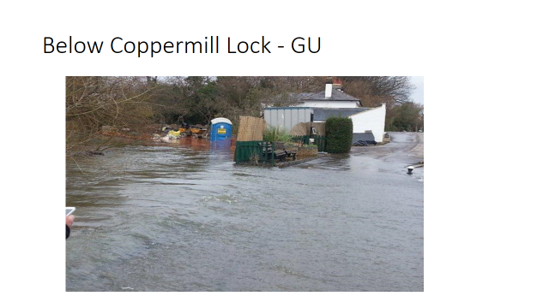

The result in some places was towpath erosion, sometimes (e.g. the K&A) threatening to undermine towpath embankments. On the Lee & Stort, the flood currents undermined some of the waterway walls.
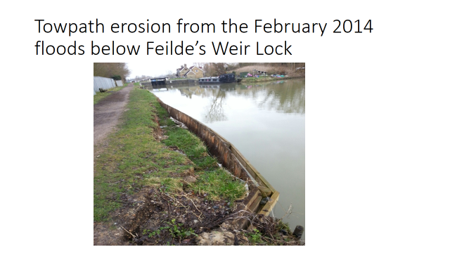
Thankfully, overall nothing very dramatic and the network showed its resilience – but my fingers are still crossed as the ground will be waterlogged in some places for some time and slippages are still possible – this is what caused the Dutton breach.
Intriguingly, there were two examples of the canals’ drainage function. The Bridgwater & Taunton was used to take pumped water away from the Somerset Levels. The Grand Union was used to move water from one river basin to another - when paddles were opened at each end of the locks between the Tring and Leighton Buzzard areas. This moved water from the headwaters of the Thames valley near Aylesbury into the Great Ouse Valley.
Volunteering
Some of you will have come across volunteer lock keepers. There were 412 of them in 2013. A recent survey of some 200 showed 86% do at least once a week with 29% giving two days. 80% said they would recommend it. 76% planned to help out over the winter on different work. The same survey showed 96% intended to come back this year and there have been another 200 applicants. There’s interesting news from those helping at Stone in Staffordshire. Not only are they reducing dog-poo by talking to dog owners and offering free poop bags but they are also talking to town councillors who were astonished to learn how many boats pass through the town each year and what benefits they could bring to the local economy. Those like me who have stopped at Stone know what a nice town it is.
The Trust has 45 community adoptions active and I’m told there are another 25 being planned. New groups vary from Leicester Rowing Club to Hanover Primary School in London. An example of how wide the waterways reach is the Wirral Autistic Society; it has own boat which it operates 5 days a week and has adopted a length in the Beeston/Tattenhall part of the Shroppie as you approach Chester. They’ve done litter picking and grass trimming and are moving on to re-painting sign posts and bollards – all part of making the waterways looked cared for. Two other examples are staff from a large Burton-on-Trent brewery and Barlaston Parish Council on the Trent & Mersey.
The Trust has its own Towpath Task Forces – there are now 50 each month covering 29 different places. Their flexibility allows people to turn up at a central point on fixed days a month – or in some cases fortnightly or weekly. In each of our 11 waterway unit areas, we have two people on volunteer planning and management. Some issue newsletters, such as Wayne Ball in Newark office, John Highmore in Milton Keynes and Tom Freeland in the Central Shires district.
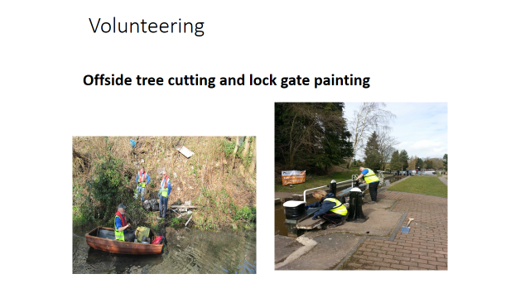
As examples of what’s being done, last autumn 42 Loughborough students joined Trust staff and Grantham Canal Society volunteers in clearing the towpath and bed of the derelict Canal near Cropwell Bishop. IWA Northampton Branch have adopted the whole of the 17 lock Flight. The Blisworth Canal Partnership has been cutting the trees in Blisworth Tunnel north cutting. Recent work near Aylesbury includes towpath repairs after flood damage and volunteers are helping with flood damage in other areas – such as near here at Stanstead.
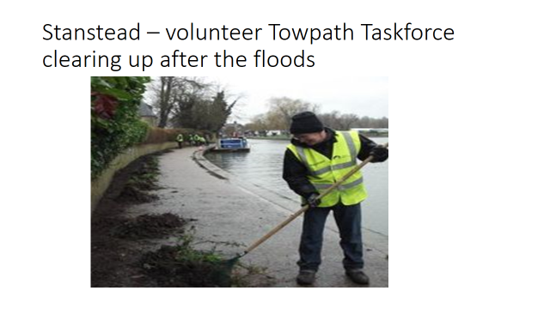
Milton Keynes IWA Branch, nobly supported by James Griffin of the long established hire firm Wyvern Shipping, last autumn collected 10 tonnes of grot from the GU, including 24 bikes; 35 IWA volunteers and 6 Trust staff working together. IWA Lichfield Branch logged over 700 hours in 2013, about double 2012’s figure, working in the Rugeley area, including two branch volunteers authorised to use Trust strimmers who, among other things, keep tidy the new moorings at Brindley Bank. Earlier this month as many as 80 people from IWA Warwickshire, Army cadets, Warwick University students, a Warwick youth group (note the young element) and local residents pulled out about 50 supermarket trolleys and over 20 bikes and other rubbish in the Leamington Spa area, under the watchful eye of the Trust’s Steve Lambert.
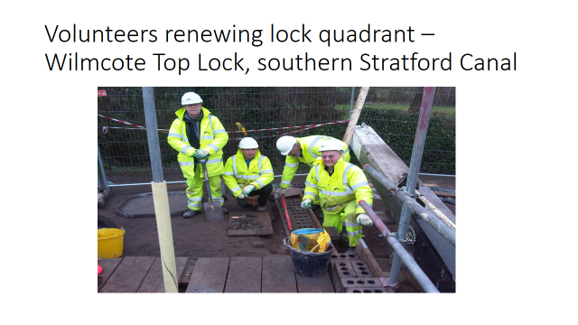

My favourite example relates to Wilmcote top lock on the southern Stratford – another story involving Steve Lambert. The bottom wing walls needed attention but the staff hadn’t the time to do it all. So 12 volunteers – in January, mind - worked in two groups over all of three weeks to cut out the defective bricks and then began re-bricking. They also worked on the lock quadrants and the brick stops you and I use to move the gates. In the fourth week, staff came to site and volunteers and staff worked together to finish the job. Great!
And you’ll recall the work of Waterway Recovery Group with the Trust’s contractors repairing those two north Oxford bridges.
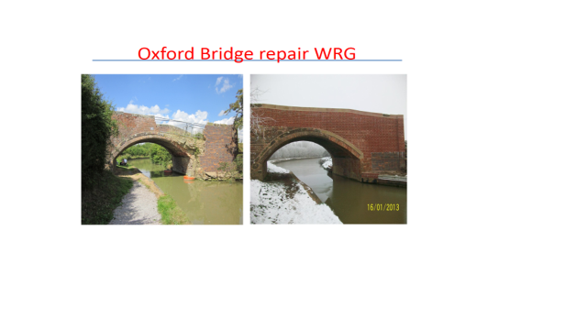
It’s not all physical work. There are volunteers at visitor welcome stations at places like Hawkesbury and Braunston. There are volunteers looking for water discharge points so the Trust can charge for this facility – and reduce pollution. There are volunteers organising other volunteers – such as at Bradford on Avon – and volunteers helping in the heritage and planning departments. The Trust wants to move from an era of “we haven’t the time to do that” to one of “I wonder if a volunteer could do that?”
What can you do to help?
Although I’ve told you about some of the things that are happening, I’d hate you to think everything in the garden is rosy. It’s not. The Trust looks after a 200 years plus old network which needs lots of TLC. There is always a list of “things to do” in the engineers’ department. There is a list of 45-50,000 defects of varying importance. Over 10% get done each year but more join the list and volunteers can help to reduce this.
2014 is an important year of anniversaries – and a reminder of what we – today’s users – have inherited. It was in 1964 that the southern Stratford-on-Avon Canal was triumphantly re-opened by the Queen Mother after David Hutchings had restored it for the National Trust, using voluntary and prison labour and proving it was cheaper to restore a canal than to close it down. This was one of the key turning points in post 1945 waterways history. How many now remember that it led on to BW and the Staffs & Worcs Canal Society restoring the Stourbridge 16 Locks in 1967 – indeed, who now remembers they were ever derelict? I know, as I was a regular volunteer there. 40 years ago David Hutchings again welcomed the Queen Mother when the Upper Avon was re-opened (again I was one of the volunteers) – as were the Caldon, the Ashton and lower Peak Forest and the Titford Canals. Those with long memories will recall a local event 39 years ago - the 1965 IWA Harlow Rally. We celebrate also this year the 100th anniversary of the birth of Robert Aickman, leader of the IWA in the dark days of the 1950s, as well as the 70th anniversary of the publication of “Narrow Boat” by Tom Rolt.
So what can we here tonight – and those not here – do to ensure this heritage is looked after?
The Trust needs more money and more volunteers – don’t get me wrong, the Trust has what it reckons is enough to prevent major breaches not being repaired (after all, Dutton got done at a £2m cost) – but there’s lots of smaller things on the “to do” list. So please think about becoming a Friend of the Trust – most people pay £3 a month or more. I’ve got some leaflets and I’d be very pleased if you would sign up now if you are not already a Friend.
Secondly, we welcome as many volunteers as we can get. Now, some of you already volunteer in one way or another – for example, as volunteer officers of this Club. But maybe you can help us get more volunteers, more groups adopting a length of their waterway. Maybe someone in this Club knows other groups – scouts and guides and army cadets. For example, last year the Herefordshire and Worcestershire Army Cadets joined in the annual BCN Clean Up.
Thirdly, can you help by taking Trust staff members on your boats? The Trust is keen that staff see the waterways from the perspective of a boat. Please contact Damian Kemp at damian.kemp@canalrivertrust.org.uk You’ll be pleased to know that Richard Parry insists that all new staff members go on a boat trip. He’s also urged staff to see things from a user’s perspective and to hear others’ experiences – whilst at the same time being an ambassador for the Trust.
Can you help with legacies maybe? After all, the Trust is a charity. I heard the other day of a gentleman who died recently and left part of his money to charities. The Trust’s share was £18,500. His partner told us about his love for the Grantham Canal along which he used to cycle and asked if his legacy could be spent on that Canal. She agreed that it could be part of the matched funding for the Heritage Lottery Fund restoration bid being put forward. The Trust also put her in touch with the Grantham Canal Society – and she now volunteers with them! So if any of you would like to think on similar lines…….!
What can you do to spread the message to the public at large? Can this Club get involved with local communities – scouts, canoeists and schools? – to use waterside facilities. For we have to remember that the Government money relates to all uses of the waterways, by no means only boats. In only 8 years’ time, we shall be talking to Government about extending the agreement. Just as we had the support of the public and their MPs in 2011, we shall need that support before 2022. So, please, invite your MPs and councillors to your events and talk to them about all the benefits the waterways bring to the country – I’ve mentioned drainage, the local economy and you can think also of the social and health benefits from towpath and other use.
And IF any of you are bereft of ideas, well, you can put money in my collecting tin!
Thank you for inviting me today. I hope you can see some of the changes taking place. May I leave you with one last thought? Once upon a time, it was “Them” and “Us” – and I was one of the “Us”. Now, aren’t we all “Us” – all wanting the best for the waterways?

There follow some questions of which advance notice had been given, together with the answers given at the meeting
Some from Di Warner & Cliff Butterworth.
“Road tax discs are being discontinued. All data is readily accessible to authorities that need to know; may paper boat Licences go the same way? It would save a lot of money with printing and postage and do away with people bothering CRT with sightings of supposed non-licensed craft that actually ARE licenced but are not displaying it. According to CRT, licence evasion is under 4%.”
Reply. This is something the Trust is looking at and has asked the Navigation Advisory Group for its view. As the question implies, the Trust’s boat checkers do not need to see the paper disc. They put the boat’s index number into their hand held device and this tells them if the boat is licenced. As I mentioned in my speech, people can go on line and see if a boat is licenced and I gave you the link. As to evasion, I can confirm that this is now below 4% nationally, a lot better than the 10% a few years ago
“Where a mooring says 48 hours/24 hours/7day, etc does the, for example, 48 hours begin when you actually moor up? Members have heard (towpath tittle-tattle?) that some Enforcement Officers consider mooring at say 18.00 as being “Day One” so you have to leave by 18.00 the next day? Surely, 48 hours means exactly that?”
Reply. Good question! Visitor mooring notices over the whole system have grown up over the last 20 years or so and many were done on a local basis. So there are inconsistencies which the Trust now wants to sort out. After all, bear in mind that licenced boat numbers have risen by about 40% from something like 25,000 to about 35,000 over the last ten years or so; so the Trust’s approach needs to reflect this. Generally, we want to move to 2 days rather than 48 hours. The Trust doesn’t monitor on an hourly basis. In some of the more popular visitor moorings there may be a ranger checking each day and we want to move to checking being done at about 12 noon. That may not always be possible, e.g. if volunteers are helping and prefer a different checking time. It’s the abuses rather than the minor infringements that matter. So if a ranger sees a boat there on 3 consecutive days, then something’s up. You mention Enforcement Officers who appear to think two days means less than 48 hours. That may have happened in the past but if you have experience of it happening to you, then do let me know and I’ll get the right person to contact you. Please bear in mind it may take a little while to put changes into effect and to put up new signs.

“On the Lea and Stort particularly as you get towards London, members are
increasingly finding they cannot get to the lock landing stages because another
inconsiderate/uneducated owner has moored and tied his/her boat to the convenient
bollards. CRT must be aware of this escalating situation so how are they
going to resolve this and when? Local signs, do’s and don’ts sheet included with
the licence? If we reported this on the 0303 number would anything be done about
it? I realise those manning the 0303 number are non CRT staff but it does not bode
well when, for instance, I rang myself last September to report a problem on the
River Stort to be asked where’s the River Stort and are you sure it comes under
CRT! “
Reply. Jon Guest tells me that some lock landing bollards on the Regents are being painted a separate colour to distinguish them from mooring bollards. The plan is to work the way round the rest. He knows this is a particular problem on the Regents and lower Lee. In addition, part of the job of the enforcement officers and, where relevant, the Mooring Rangers is to explain to offending boaters what they are doing wrong and get them to move on as this behaviour is quite unacceptable. As Trust staff can’t be everywhere, it helps if boaters join in explaining to people that lock landing stages are only for use when working a lock. As to reporting such cases, probably better to let the Enfield office know.
Now about the 0303 number. The Trust has an outsourced dedicated team who take calls from 8am till 6pm Mondays to Fridays. It’s better than having telephonists dotted around the country. Whilst they can’t be experts in everything the Trust does (any more than BW telephonists were), they are well equipped to direct the enquiry to the right place. So I am surprised they didn’t know the Stort is a Trust waterway. If this kind of thing happens again, then please let me know – with full details of the problem, when you rang and to whom you spoke and I can have it taken up. All 0303 calls are logged (not recorded) and so a follow up is possible.
“Di wanted to report Ponders End electric lock was out of action (again) on Saturday. She rang the 0303 number at about 5.25pm but no-one answered (and there was no ansaphone message)!? I thought this number was manned at weekends so why wasn’t it answered? Apart from dialing 999 option in an emergency, but this doesn’t seem appropriate or warranted if it is water related, what are we supposed to do? Please confirm the days and manned hours of the 0303 number and is there a local alternative in case this happens again? “
Reply. As I said, the 0303 number is manned from 8am to 6pm Mondays to Fridays. There is an ansaphone message out of hours which gives the emergency number. I have passed on the fact that Di didn’t get the ansafone message and, as a result, the relevant Trust person is making test calls this weekend.
The emergency number is 0800 479947. Clearly only for emergency use. The website gives some examples of what is not an emergency, such as unlicenced or speeding boats; customer facility breakdowns; reporting damage. If you are not sure whether it is an emergency, I’d rather you rang and let the Trust staff decide. If it’s to do with water levels, then remember the Trust has water level sensors in many places which automatically tell our engineers if water levels vary significantly. You imagine how busy they got in the floods period.
As to Ponders End Lock, Jon Guest’s knew of the problem through the water level sensor system and local staff went to check it. It’s a serious problem and one of the central Mechanical and Electrical team is looking at a long term answer; in the meantime, the local team have managed a temporary fix so the Lock is working again. Indeed, as you know, there are double locks here anyway.
This is the kind of thing I suggest could be left on the 0303 ansafone so the staff can pick it up on the next working day. But, as Di told us, the ansafone message wasn’t on, so she can’t win. But, as I’ve said, that’s being tested this weekend.

From John & Helen Smith
“Birmingham and London City Centres are iconic destinations for cruising boats. Birmingham, being located at the centre of the system sees far more visiting boats than London yet the boating experience is so very different.
How would you summarise the difference between these two City Centres waterways and how do you think these differences relate to how each City manages its waterways?”
Reply Wow! Any Brummies here to get upset? I like Birmingham. I like London. But they are different, aren’t they? Maybe one reason is there’s one council in Birmingham but lots in London. Birmingham (and the property developers) had the vision to create Brindley Place and the surrounding area. Having the crossroads with the Oozells Street Loop helps. I can’t immediately think of anywhere similar in London. But then London for years has had Little Venice – and now the Paddington Basin Arm - and the Kings Cross amphitheatre and Broadway Market have their fans. London has a lot more moored boats – which is a separate issue of its own and I mentioned earlier what the Trust is trying to do on that matter. In summary, I’d say Birmingham is more vibrant – it is much helped by having a towpath on each side – and that planning matters about the use of adjoining land is so important.
From Robbie and Sue Barrett
“In view of the dreadful flooding in various parts of the country partly due to neglect and lack of dredging over many years, EA are committed to dredge the Somerset Levels and hopefully some other waterways.
Will CRT be reviewing its current policy to only spot dredge when required or does it have a more ‘hands on’ policy now to ensure that the whole of the Lee & Stort is properly maintained?
For information, below Lower Lock and Hunsdon Lock, silt has already built up enough to stop boats mid-stream preventing them getting into the lock!”
Reply I’ll avoid the Somerset Levels flooding question as that an EA matter! I mentioned earlier generally what the Trust is doing about dredging – increase the budget. As you know, who is responsible for what on a river navigation isn’t always obvious. For example, river sections are not owned by the Trust. But the locks and lock cuts are and keeping the cuts clear is essential for navigation – as distinct from flood control. Floods are always likely to cause silt bars. Your waterway manager Jon Guest tells me that he knows of the problems you mentioned and that he plans to dredge there. To avoid disposal costs, the plan is to remove the high spots into deeper areas. In addition, a dredging survey is currently being undertaken of areas where boats have recently had problems. If you want more detail, then please ask Jon Guest. I don’t know when any Club member last had him on a Club boat but what about inviting him along these sections?
“Working Boats and Butties
A little while ago we read somewhere that commercial craft were going to have to
keep their butties with then at all times as opposed to what happens often nowadays where the butty is left somewhere secure while the owner takes the motorised boat on his travels for his/her business.
If this is true, what is the logic behind this as on narrow beamed canals this will incur double the use of precious water plus taking them much longer to complete their journeys? It goes without saying that when pulling a butty the motor boat’s fuel consumption will also increase producing more fumes and costing the operator more money.”
Reply. I don’t think there’s anything to worry about here and possibly things have got jumbled up. Under normal boat licences rules, the 50% discount for butties applies where a butty is paired with a motor and its licence runs concurrently with its paired motor’s. Under the new Business Licence arrangements which covers boats used for trading, the 50% butty discount applies when the butty travels with a motor boat that carries a valid trading licence – i.e. when carrying domestic fuel. Neither set of rules say that a butty cannot be left unattended whilst the motor with which it is usually paired travels separately.
Robbie/Sue – if you know of cases where what I’ve said isn’t being applied, let me know.
From Glynis Dennis
“I have been reading “The Towpath”, and there is an article in there from NABO requesting that C&RT have a "welfare & boating liaison manager". So that when C&RT want to legally remove a boat, this person liaises with C&RT and Social Services etc to ensure that the legal process is deferred. .As C&RT are not a Housing Association or Social Services, I do not see why my licence money should be spent on this.”

Reply. In difficult cases where someone hasn’t paid their licence fee or isn’t moving on as the rules say and the person on the boat has a health of financial problem, the Trust tries to see whether there’s a problem to be resolved. In relevant cases, we bring in outside agencies or one of the waterways chaplains if there is one in that area. The chaplains have been very useful, specifically in helping to access benefits etc and therefore be able to pay what they owe when before they couldn’t. Sometimes they can help move people off boats onto land to places that suit them better. The Trust knows of the NABO idea. The Trust is looking at whether the chaplain idea can be expanded and/or whether working with a housing charity might help. These would be our preferences as they would have the relevant skills locally before employing a nationwide welfare officer. As to using licence money, please bear in mind that spending a bit of money to avoid enforcement costs (including possibly court costs) can have its attractions.
From Keith and Carole Alderton
“As a Charity, CRT is currently raising funds to become “self sufficient” when State
funding stops. How large will the financial gap be when State funding stops and what measures are in place to fill this gap?”
Reply. Let’s set out the background. In the current year (to 31 March 2014) \the Trust’s total income is expected to be about £165m. £39m of this - about 25% - comes from the Government contract (rising to £50m in 2015-6). The contract runs for 15 years from 2012 and the Trust has a certainty about this source of income which was denied BW. As the Trust doesn’t want to find the contract stops, as it were, overnight, there is (in the terms of the contract) to be a review in year 10 about its extension beyond Year 15, including the amount. Now, I don’t have a crystal ball and so I don’t know what will happen. Yes, the Trust wants to increase its income from other sources – all charities do – but the absence of that crystal ball means that I don’t know by how much the income will increase. So, Keith, I can’t answer your question on how much the “gap”, as you put it, would be.
The question assumes the Government funding would stop completely. As that’s not my view, let’s look at why the Government agreed to the contract in the first place and consider whether the arguments are likely to apply in the future. The Government is very aware of three particular benefits it gets – so much aware that the contract measures them. First, it wants to see that the key infrastructure assets are kept in good order – such as embankments and locks and tunnels and bridges and reservoirs. Secondly, it wants to see the towpaths kept in good order. Thirdly, it wants flood defence mechanisms kept in good repair. Underlying the Government contract was the acceptance that the cost of doing this couldn’t be met by charges on users (and the Government were keen on continued free access on foot to towpaths – in the aftermath of the Forestry row) or by other income and so a Government sum was needed. There are also other Government benefits and objectives to consider, such as land drainage, the rural economy, tourism, improved health, industrial heritage etc. I can’t see these aspects disappearing.
Renewal negotiations with Government won’t be easy – nor should they be. The Trust will use the intervening years to reduce its costs and to increase its own income as much as possible – from its Endowment fund mainly from property rentals; from cable and water companies; from donations and legacies etc; and, Yes, from users. I have already mentioned that the Trustees decided that for a three year period boat licences are going up only in line with inflation and I cannot see this type of income filling any gap.
Just as the move from BW to the Trust had wide political and public support, I see the same being needed in about 8 years’ time. That means not this Government, nor the next, but probably the one after that! But it means we have to go on building up support for the Trust so that Government will not want to mess with the current type of contractual arrangements. I have mentioned earlier tonight why I think people should join the Trust as Friends and I repeat that now. The more Friends, the more income and the more public support to show the Government.
Overall the old government grant was not only arbitrary and uncertain, but over time it fell from c£70m to the current £39m – thank goodness property rentals and other income rose. Now it is certain and set to rise from 2015/16. If we want the contract to continue after 2027, it’s in now our hands to do something about it.
Further questions asked on the night were follow up points on those above, apart from one about the possible transfer of EA waterways to the Trust. The reply said it was still Government policy that the transfer takes place; matters that needed resolving were exactly what would be transferred e.g as different river navigations had different arrangements about flood control weirs/locks and navigation weirs; and how much the Trust would receive for taking on the liabilities

